**This is a bonus lab, it can be used to get one bonus mark applied to any lab that is not 5/5.**

**This lab requires a camera to demonstrate your successful installation and demonstration of an app running using RPGLE code accessing a database on our IBMi.**

**If you do not have a camera, you can install an emulation program allowing you to share your screen to demonstrate what was described in the paragraph above.**

**Lab objectives:**

**Install LongRange on your mobile device or emulation program.**

**Configure a new profile on your mobile device allowing you to access the demonstration apps running off of an IBMi system**

**Requirements to earn the lab bonus mark:**

**Answer the question at the end of this handout.**

**Demonstrate the following mobile app and its code**

|  |  |
| --- | --- |
|  |  |

Install LongRange using either Google Play or the App Store.

Set up a profile called Yourname Demo. (Use your actual name.)

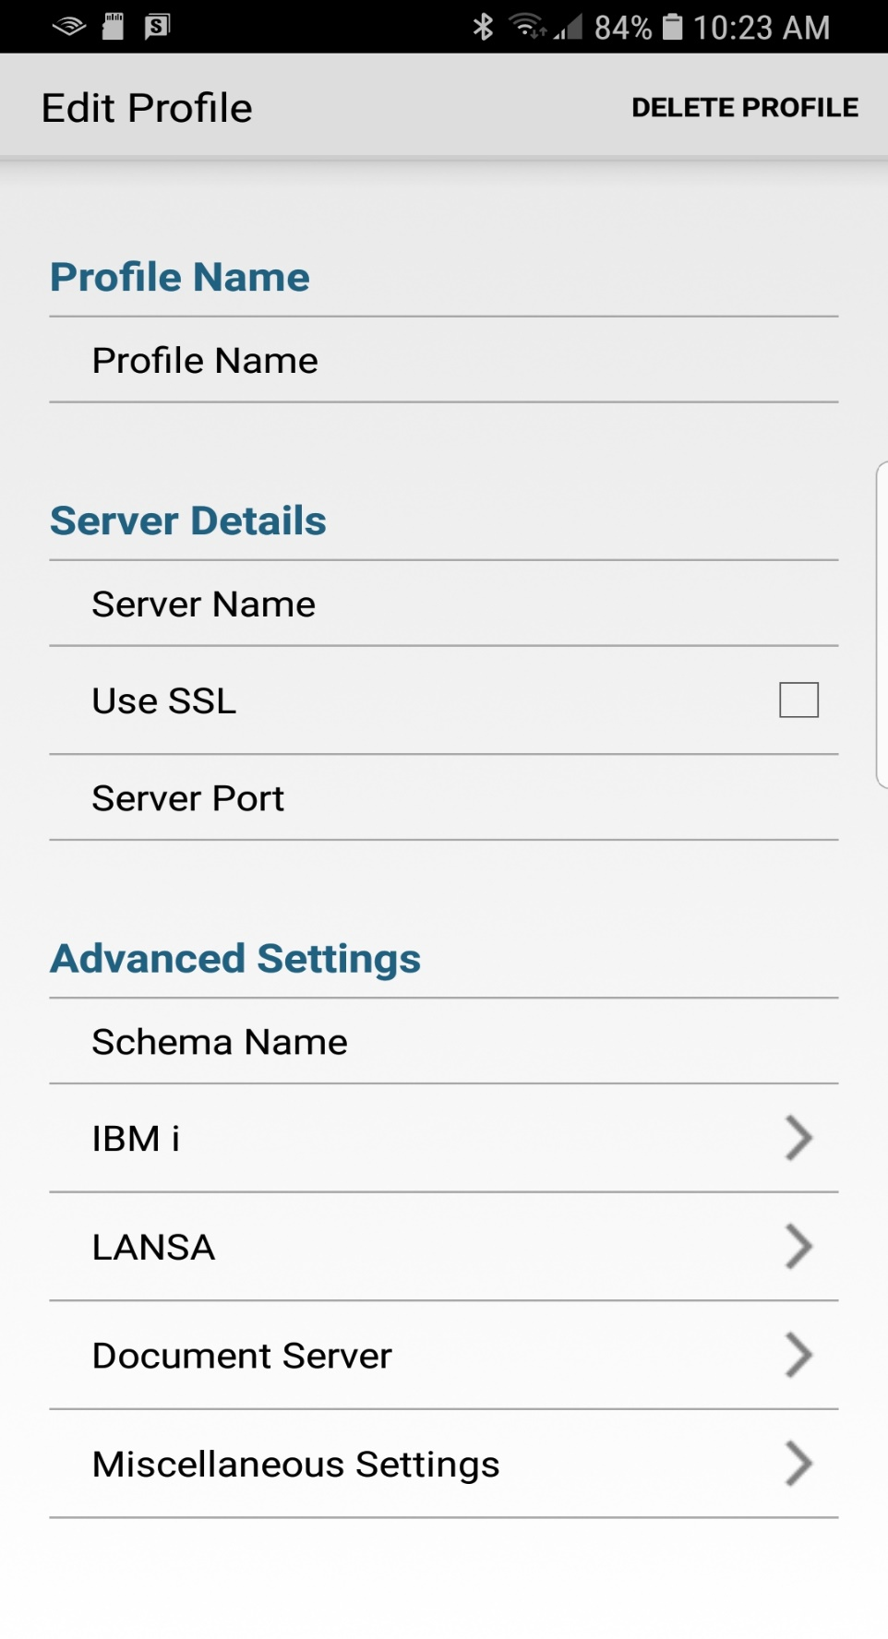

Your instructor will give out the above information in class. If you miss this class, get the information from a classmate. The password for LRNGUSER is MAP525.

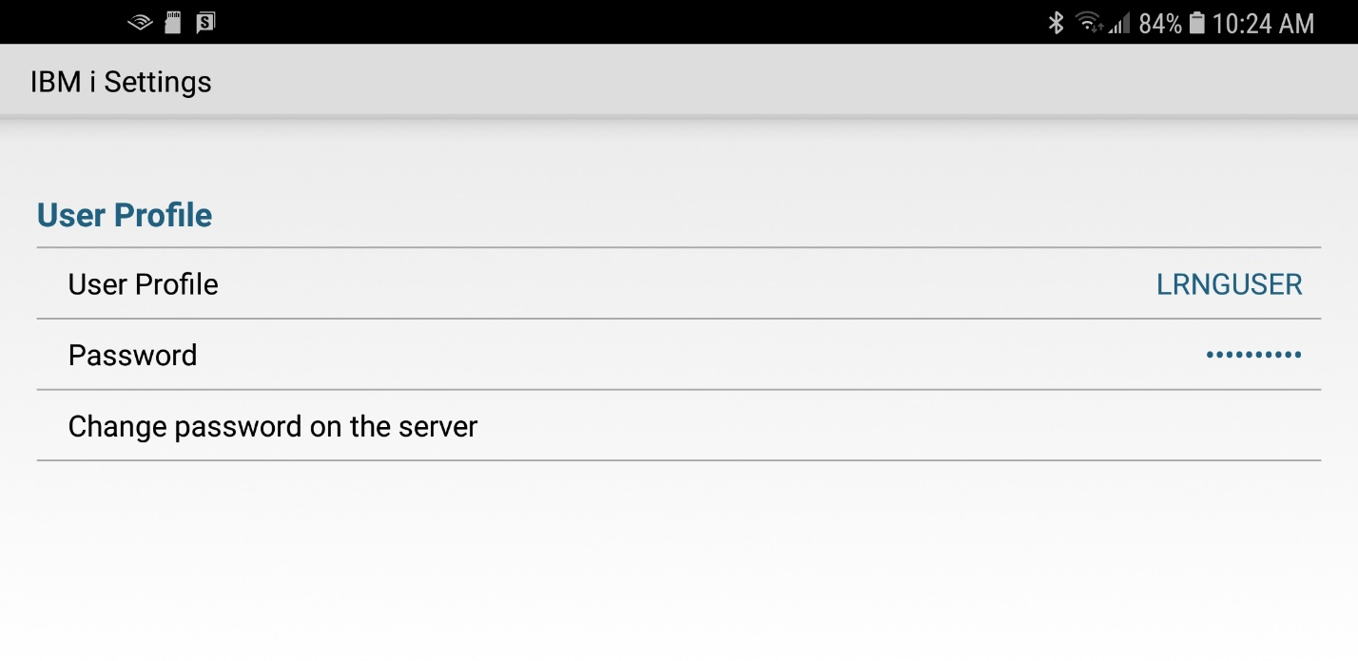

In order for the above mobile app to run a directory is installed in the IFS called AXES. Also, some additional libraries are added.

What are all the extra libraries intalled on our system that support extended RPGLE and DDS allowing mobile apps to run? (Hint all the libraries start with LRNG)

________________________________ ______________________________________

________________________________ ______________________________________

________________________________ ______________________________________

________________________________ ______________________________________

________________________________ ______________________________________

Use the WRKACTJOB command.

What is the name of the Subsystem/Job that runs supporting mobile apps

____________________________